**COE718 Final Project (Media Center) Interim Report**

**Introduction:**

The requirements for this project are to implement a “Media Center” using Kiel uVision and load it to the LPC1768 board using the knowledge and technique obtained from the pervious labs. The Media Center program consists of three different parts, which include a Photo Gallery, which displays 4 pictures, an MP3 Player that streams an audio file through the USB port of the computer, and a Game of the designer’s choice. So far, as demonstrated, the photo gallery and the MP3 player were completed successfully.

**Hardware:**

The hardware portion for the media center revolves around the board’s controls and the hardware of the transferring the audio file from the computer to the board. The main feature or control used is the joystick as it is used to navigate through all the menus, selecting and moving the cursor. Another equally important feature is the LCD as it is in every part of the media center, which displays the menu, the images, and the text to navigate through. The speaker on the MCB1700 is used for playing audio from the PC during the audio program and the potentiometer is used to change the level of the volume. The LEDs are not used as much, so for future task the LEDS can be added to all the features of the media center.

The audio is played on the board through the hardware of the board and the pc transmitting the audio file. The MP3 file sends a digital signal to the board through the USB Port. The program encoded on the flash memory of the board will convert the file to an analog signal. The analog signal can be used to change the volume of the signal before being outputted. The analog signal is then convert back to a digital signal and outputted to the speaker.

**Software:**

The software side of the project is where most of time and resources are used. The first component of the media center is the menu where the user can select the feature (list above) that they want to explore. A simple red and white colour scheme was chosen to ease reading and improve clarity. The user knows which option the selector is on based on the colour of the text, which turns yellow when the joystick is, moved up/down.

Figuring out ways to include pictures on the MCB display proved difficult, as the standard picture formats do not work. Conversion to C code is necessary, with some extra steps taken to remove parts of the code that were not needed. Once the photo gallery option is selected from the main menu, a list of four images comes up which allows the user to select which photo they want to display. Once select is pressed, the picture is displayed and a text with the image description is displayed above the image. A LEFT press makes the user to go back to the photo gallery menu from where they can select other photo(s) to display.

The audio portion of the media center is very basic at this point. Once the selector chooses this option from the main menu, an screen displays shows that the audio player was selected, then the streaming port is opened and once audio is playing from the PC, it will be outputted through the MCB1700, onto the board’s speakers. The audio can be played from a MP3s file from the PC or a YouTube video can be opened. The function for the audio to stop and go back to the main media center has not been implemented yet.

So far for the game, the game has not been implemented but the intro window and the instruction windows have been coded. The game that is to be implemented is Space-Jump, which is similar to doodle-jump. The implementation is not yet done but the idea is there and the process will begin as soon as possible.

**Flow Chart:**

The Flow chart below shows how the main menu and the sub menus interact.

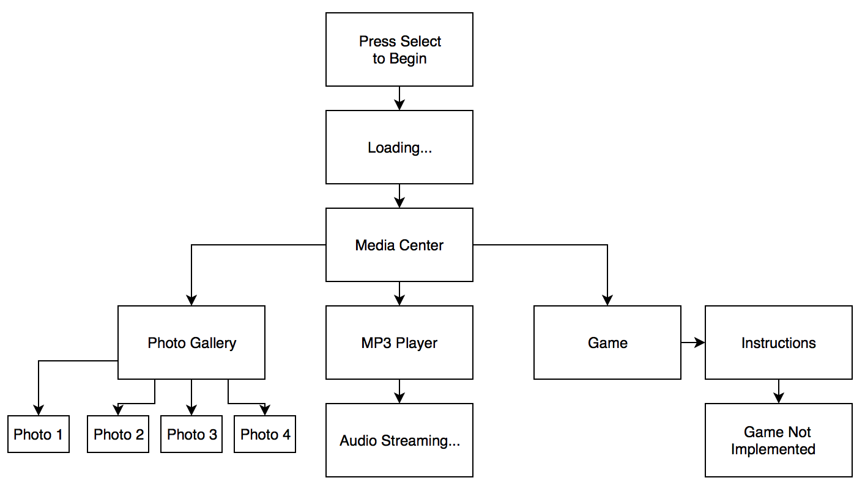

**Conclusion:**

This final project at the moment is coming along well. There are a few bugs that need to be fixed otherwise, the program works correctly and displays accurate results. The image gallery is complete and the audio streaming is also complete and the only thing left to complete is the game. Looking at how the project was put together it would be possible to add or modify parts of the chain as they were put together in an independent way. The project at the end is expected to meet the requirements and run as planned. In conclusion, the media centre is going well, the only thing that needs a lot of work is the game, which is scheduled to finish when it’s required to be with full functionality.

**References:**

[1] Gul Khan. COE 718. *Project: Media Centre Project.* Ryerson University, Fall 2019.